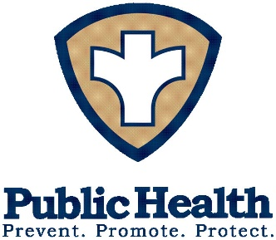

Southwestern District Health Unit

227 161h St. West Dickinson, North Dakota 58601
Telephone: (701) 483-0171
Toll Free: 1-800-697-3145

□ Application /□ Renewal

□ Restaurant (RE) / □ Limited Restaurant (LR) / □ Bar & Tavern / □ NL /
□ Multiple Food / □ BA/□ Beverage

The undersigned is familiar with North Dakota Century Code (NDCC) Chapter 23-09 - Lodging Establishments and Assisted Living Facilities, and with Chapter 33-33-04 of the North Dakota Administrative Code (NDAC) dealing with the sanitary requirements for food establishments.

The undersigned certifies that the facility for which application is made will be operated in compliance with the requirements of the above mentioned statute and rules.

(Failure to submit an application and fee as stated under NDCC 23-09-16 may result in legal action. Any person violating the provisions of this chapter may be charged with a Class - B misdemeanor.

PLEASE PRINT LEGIBLY:

Name of Establishment |  | License Number
Name of Owner |  | Telephone Number
Email Address |  | Cell Phone Number
Mailing Address | City | State | Zip
Establishment Address | City | State | Zip
LICENSE FEE: □Seating Capacity-0-100 $100.00 □Seating Capacity-101-500 $125.00
Payable to SWDHU (Southwestern District Health Unit)

Return the application & fee to: Southwestern District Health Unit
For Office Use Only
Date received:
Rcpt #:
Check #:
$ Amount:
Recorded:

Seating Capacity

227 16th St. West

Dickinson, ND 58601

Signature of Owner/Manager Date

